Which of the following number is associated to each point on a co-ordinate line?
An integer
A real number
A rational number
A natural number

-------------------- planes intersect at right angle to form three dimensional space.
Three
Four
Eight
Twelve
At each point of domain, the function ----------------
Is defined
Is continuous
Is infinite
Has a limit

Let R be a closed region in two dimensional space. What does the double integral over R calculates?
Area of R.
Radius of inscribed circle in R.
Distance between two endpoints of R.
None of these

What is the relation between the direction of gradient at any point on the surface to the tangent plane at that point ?
parallel
perpendicular
opposite direction
No relation between them.

Two surfaces are said to intersect orthogonally if their normals at every point common to them are ----------
perpendicular
parallel
in opposite direction

If 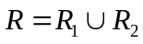 , where 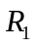 and 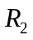 are no overlapping regions then
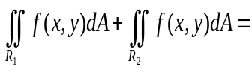
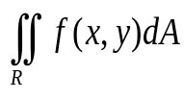
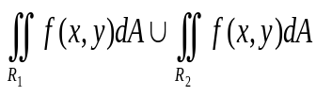
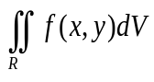
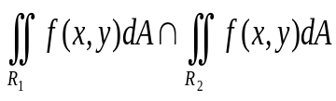

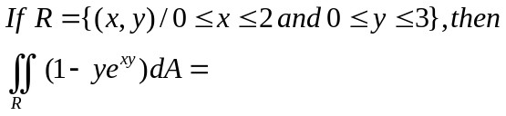
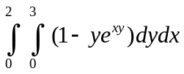
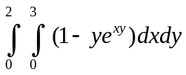
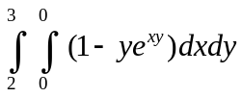
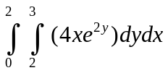

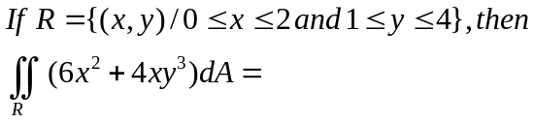

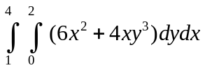
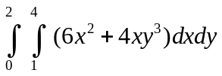
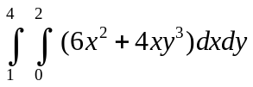
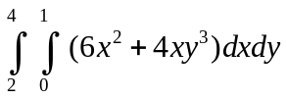
Which of the following formula can be used to find the volume of a parallelepiped with adjacent edges formed by the vectors , and ?

Let the function 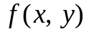 has continuous second-order partial derivatives 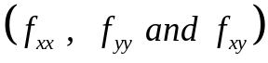 in some circle centered at a critical point 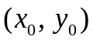and let 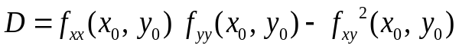

If 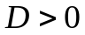 and 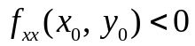 then 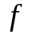 has ---------------

Relative maximum at
Relative minimum at
Saddle point at
No conclusion can be drawn.

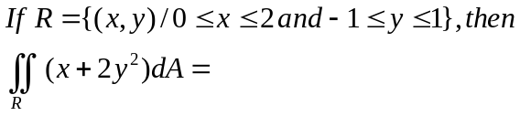
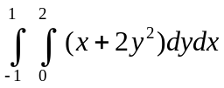

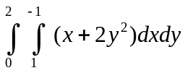
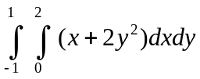
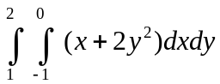
Let then by chain rule 

